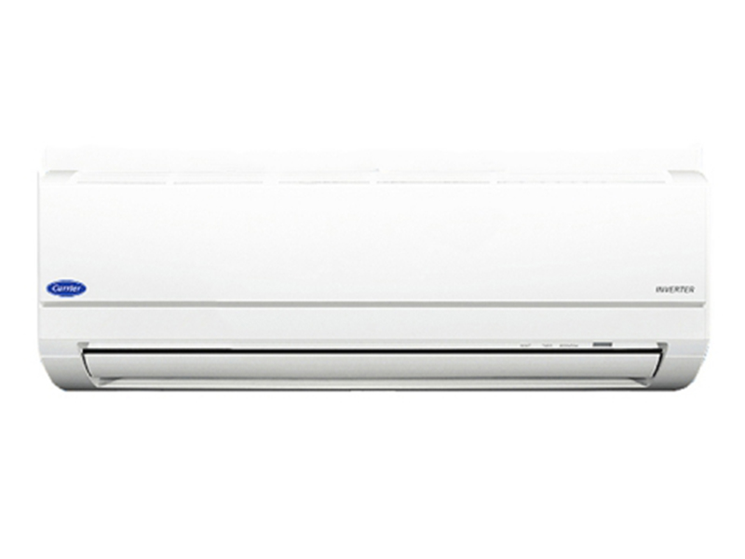

**9.450.000đ**

**Carrier Inverter 38/42 GCVBE 013 12,000 BTU air conditioner**

**Specifications**

* Type of air conditioner1 pm
* Usable area< 20m2
* Installation typeWall mounted
* Inverter technologyHave
* Wattage1.1KW
* Voltage source220V - 240V / 50Hz
* Guarantee24 months
* Made inThailand
* Brand originAmerica

**Indoor unit parameters**

* Size of indoor unitWidth x height x depth *(79.8cm x 29.3cm x 23cm)*
* Volume of indoor unit10kg
* Cooling capacity12.000 BTU - 1.5HP

**Outdoor unit parameters**

* Size of outdoor unitWidth x height x depth *(66cm x 55cm x 24cm)*
* Mass of outdoor unit22kg
* Gas usedR32

**Product information**

## Introducing the Carrier Inverter 38/42 GCVBE 013 air conditioner

**Self-cleaning function + "Aqua resin" anti-stick coating**

[Carrier Inverter 38/42 GCVBE 013 air conditioner](https://meta.vn/dieu-hoa-carrier-inverter-38-42-gcvbe-013-p77471) is equipped with leading advanced dual cleaning technology to minimize condensation of water and oil, prevent dust from sticking to the radiator fins, and prolong the life of the machine.

**Self-cleaning function**

After turning off [the air conditioner](https://meta.vn/dieu-hoa-c1018) , the cooling fan will automatically run for about 20 minutes to dehumidify to help minimize the formation of mold.

**Inverter technology**

[Carrier GCVBE 013 1-way air conditioner](https://meta.vn/dieu-hoa-1-chieu-c1039?brands=2633) is equipped with the latest inverter technology, helping to save energy effectively, operate smoothly, and achieve high cooling efficiency.

**Lightning protection equipment**

The board is integrated with a lightning absorber to protect the device from high voltage currents of up to 10,000 voltages. In addition, the GCVBE 013 [1-way air conditioner](https://meta.vn/dieu-hoa-1-chieu-c1039) is also equipped with an anti-noise filter to prevent voltage fluctuations. Since then the machine has worked well with high reliability.

**E-box anti-insect box**

Important electrical circuits are protected by E-boxes to prevent insects from entering.

**Fireproof layer**

The electrical boxes of the outdoor and indoor units are protected by a fire-resistant membrane.

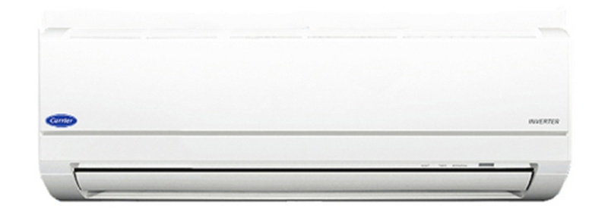

Carrier Inverter 38/42 GCVBE 013 air conditioner.

**Note:** Product images are for illustration purposes only, product details, colors, designs and specifications may vary depending on the actual product without prior notice.